1. ***SELECT Queries***
2. List of employees in whose name "Ni"/"ni" is mentioned, with a list of detected crimes for each.

SELECT E.f_name, E.t_name, C.crime_id

FROM Employee E, Is_investigating I, CRIME C

WHERE (E.ID_EMPLOYEE = I.Chief_id or E.ID_EMPLOYEE = I.Partner_id) AND I.Cr_id = C.crime_id

AND C.is_solved = 'Y'

AND (E.f_name like '%Ni%' OR E.f_name like '%ni%');

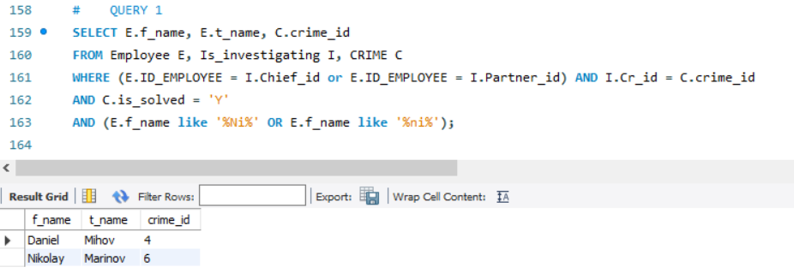

1. For a perpetrator named “Geno”, a list of all other criminals with whom he was involved in the commission of 2 or more crimes.

SELECT C.f_name,C.t_name,C2.f_name,C2.t_name

FROM CRIMINAL C, Is_commited I,CRIMINAL C2, Is_commited I2

WHERE (I.Main_perpetrator_id=C.Criminal_id or I.Crime_partner_id=C.Criminal_id)

and (I2.Main_perpetrator_id=C2.Criminal_id

or I2.Crime_partner_id=C2.Criminal_id)

and I2.Crime_id=I.Crime_id

and C.f_name not like C2.f_name

and C.t_name not like C2.t_name

and C.f_name like "Geno"

GROUP BY C.f_name,C.t_name, C2.f_name,C2.t_name

HAVING count(distinct I.crime_id)>=2

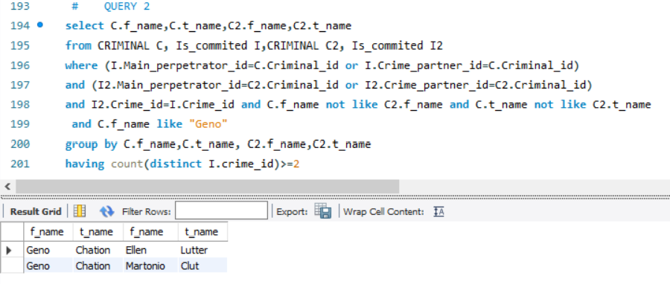

1. Recapitulation for the whole of 2015. : total number of committed crimes; total number of detected crimes; ratio of crimes with disclosure to those without subsequent disclosure.

SELECT TotalCrimes , SolvedCrimes, (TotalCrimes-SolvedCrimes)AS UnsolvedCrimes ,

SolvedCrimes/(TotalCrimes-SolvedCrimes) AS Ratio

from (SELECT COUNT(crime_id) as TotalCrimes

FROM crime

) all_crimes ,

( SELECT COUNT(*) as SolvedCrimes

FROM crime

WHERE is_solved like 'Y'

) resolved ,

crime C

WHERE C.dateOpened >= '2015-01-01' AND C.dateOpened <= '2015-12-31'

